3 rd party tools - Open source

- Prometheus
- Grafana
- Alert manager

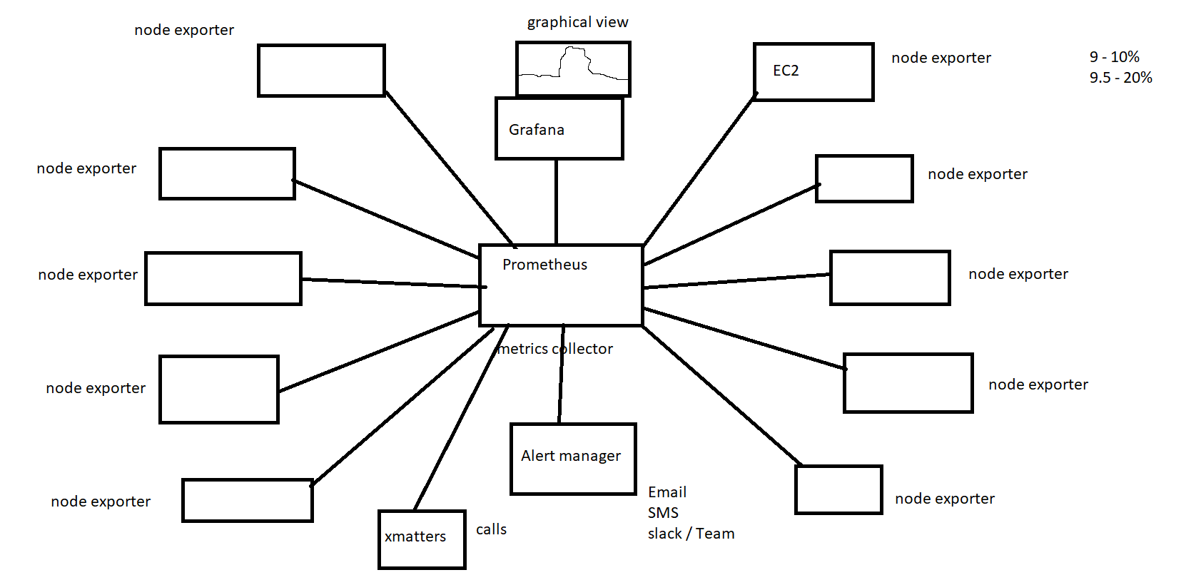

step 1: In security group add the below ports

9090
9100
3000

FOr prometheus installation:

yum update -y
2 wget https://github.com/prometheus/prometheus/releases/download/v2.32.0-beta.0/prometheus-2.32.0-beta.0.linux-amd64.tar.gz
3 ls
4 tar -xvf prometheus-2.32.0-beta.0.linux-amd64.tar.gz
5 ls
6 mv prometheus-2.32.0-beta.0.linux-amd64 prometheus-files
7 sudo useradd --no-create-home --shell /bin/false prometheus
8 sudo mkdir /etc/prometheus
9 sudo mkdir /var/lib/prometheus
10 sudo chown prometheus:prometheus /etc/prometheus
11 sudo chown prometheus:prometheus /var/lib/prometheus
12 sudo cp prometheus-files/prometheus /usr/local/bin/
13 sudo cp prometheus-files/promtool /usr/local/bin/
14 sudo chown prometheus:prometheus /usr/local/bin/prometheus
15 sudo chown prometheus:prometheus /usr/local/bin/promtool
16 sudo cp -r prometheus-files/consoles /etc/prometheus
17 sudo cp -r prometheus-files/console_libraries /etc/prometheus
18 sudo chown -R prometheus:prometheus /etc/prometheus/consoles
19 sudo chown -R prometheus:prometheus /etc/prometheus/console_libraries
20 vi /etc/prometheus/prometheus.yml
21 chown prometheus:prometheus /etc/prometheus/prometheus.yml
22 vi /etc/systemd/system/prometheus.service
23 sudo systemctl daemon-reload
24 sudo systemctl start prometheus
25 sudo systemctl status prometheus

http://<public-ip>:9090

------------------------------------------------------------------------------------------------------------------------------

For grafana Installation :

vi /etc/yum.repos.d/grafana.repo
------
[grafana]
name=grafana
baseurl=https://packages.grafana.com/enterprise/rpm
repo_gpgcheck=1
enabled=1
gpgcheck=1
gpgkey=https://packages.grafana.com/gpg.key
sslverify=1
sslcacert=/etc/pki/tls/certs/ca-bundle.crt
--------
yum install grafana-enterprise
systemctl daemon-reload
systemctl start grafana-server
systemctl status grafana-server

http://<public-ip>:3000

step3 :

go to the grafana dash board

- add the data source and select prometheus and give the prometheus url
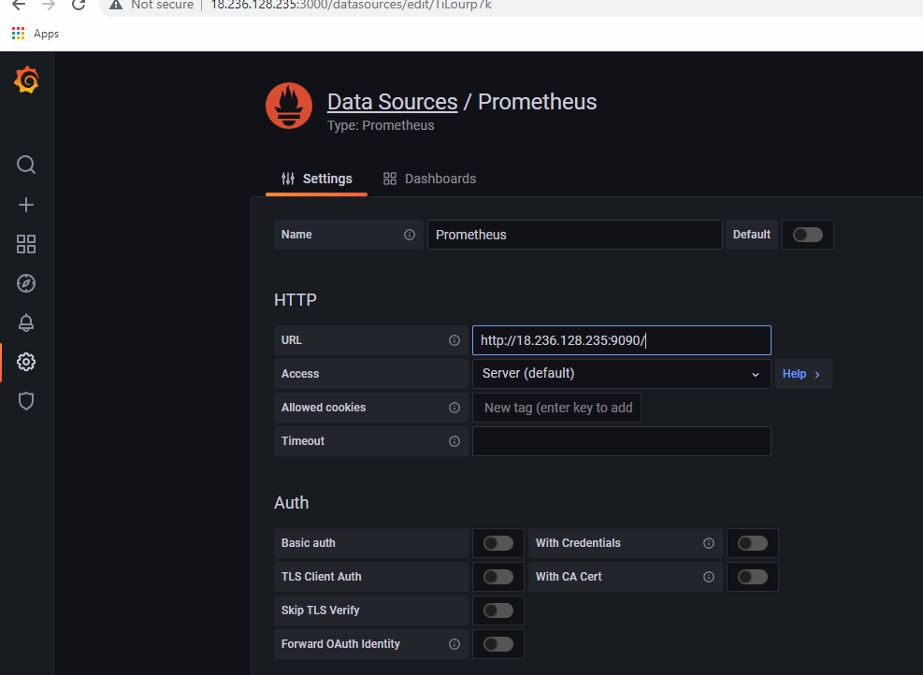

step 2 :
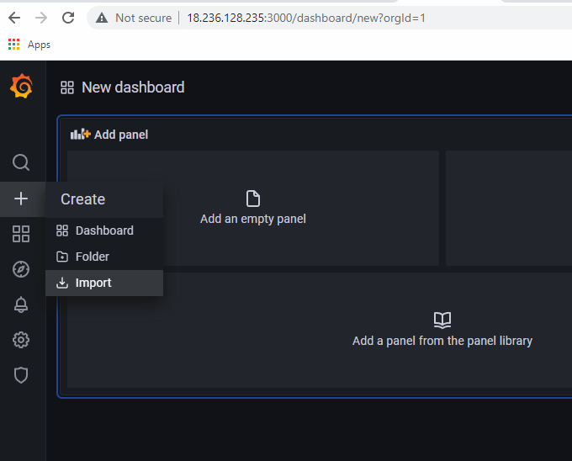

Step 3:
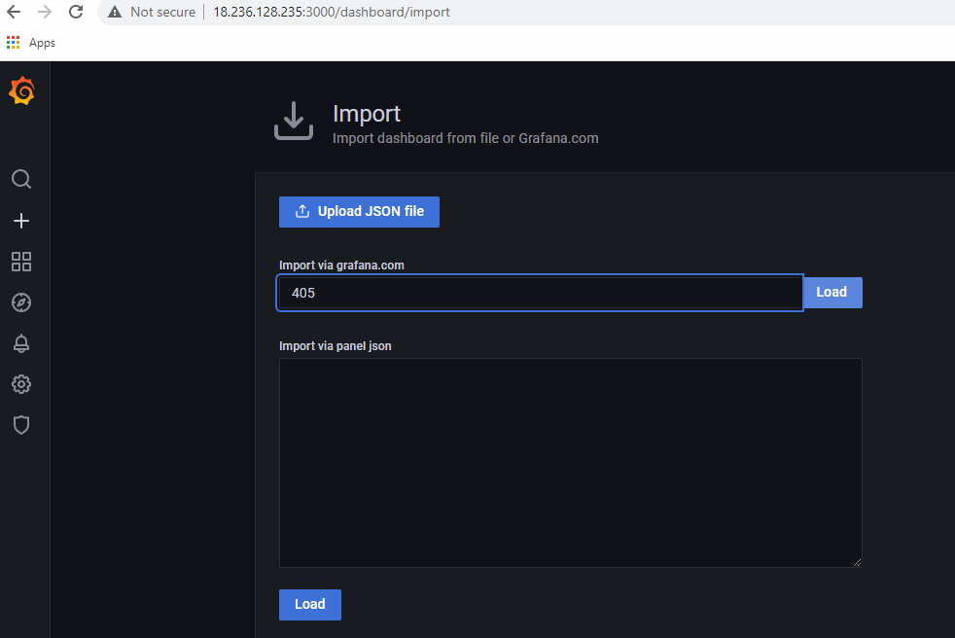

4. Node exporter installation on client

2 wget https://github.com/prometheus/node_exporter/releases/download/v0.15.2/node_exporter-0.15.2.linux-amd64.tar.gz
3 tar -xf node_exporter-0.15.2.linux-amd64.tar.gz
4 sudo mv node_exporter-0.15.2.linux-amd64/node_exporter /usr/local/bin
5 sudo useradd -rs /bin/false node_exporter
6 vi /etc/systemd/system/node_exporter.service
7 systemctl daemon-reload
8 sudo systemctl enable node_exporter
9 sudo systemctl start node_exporter

5. Adding the client server to prometheus server to produce the metrics

vi /etc/promethues/prometheus.yml

targets

systemctl restart prometheus

Task :

send alert to gmail

https://grafana.com/blog/2020/02/25/step-by-step-guide-to-setting-up-prometheus-alertmanager-with-slack-pagerduty-and-gmail/

